**CONFIRMED! DROP OFF THE ITEM(S) WITHIN 10 DAYS!**

Print your return labels, pack the item(s) and take the box to the carrier. Make sure to drop it off within 10 days to avoid getting your size exchange cancelled.

MY ORDER

**EXCHANGE STARTED**

**Tracking**

Number: [281261963083](http://fedex.com/Tracking?action=track&language=english&cntry_code=us&tracknumbers=281261963083)

Carrier: FedEx

**SHOW THIS QR DURING DROP-OFF**

Take your package to a [FedEx location with a QR code scanner](http://www.fedex.com/easyreturns) and show this code from your smartphone. FedEx will then print a label for you.

**Your return label**

4007881782

**OR PRINT A LABEL**

Print the label, stick it on the box and drop off your package at a FedEx location.

[**GET RETURN LABEL**](blob:https://www.adidas.com/e4019d9c-1e6e-45ec-9bc8-2af6c85631f1)[Find drop-off locations](https://www.fedex.com/locate/index.html?locale=en_US)

**HOW TO EXCHANGE?**

1. Print your return label. No printer? Simply save the return FedEx QR code or return label on your mobile device to show during drop off.
2. Pack the item(s) you want to exchange.
3. Seal the box and stick your return label over the previous delivery label, or show the return FedEx QR code or return label during drop off.
4. Bring your package to a return drop off location. More details on return drop off locations can be found at <http://www.fedex.com/easyreturns>

**WHEN DO I RECEIVE IT?**

As soon as your return is scanned by the carrier, your right size(s) will be shipped. You'll receive a shipping confirmation email with a tracking code when it leaves our warehouse. We will use our standard delivery service for your exchange order.

**1 ITEM**

[[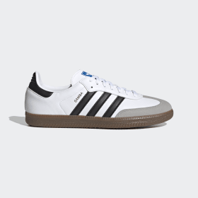](https://www.adidas.com/us/samba-vegan-shoes/H01877.html)](https://www.adidas.com/us/samba-vegan-shoes/H01877.html)

*[EXCHANGE](https://www.adidas.com/us/samba-vegan-shoes/H01877.html)*

SAMBA VEGAN SHOES

H01877

Cloud White / Core Black / Gum

8 (Men's)

$63

~~$90~~

**Exchange for size 7.5**